
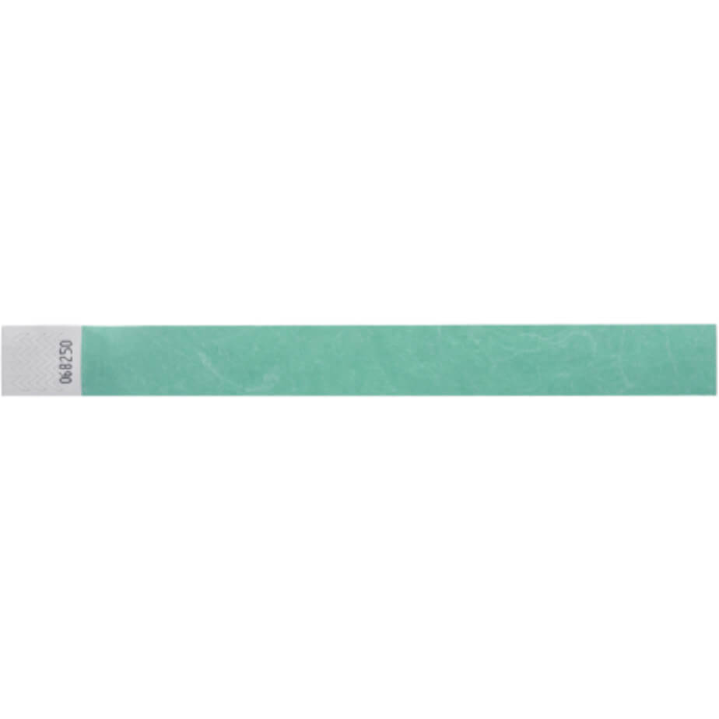
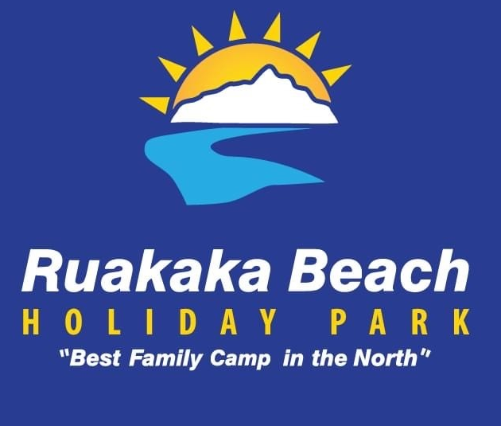
Wristbands must be worn at all times

Nau Mai Haere Mai

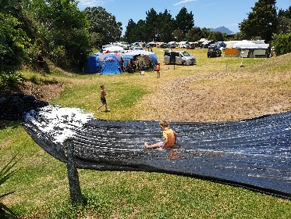

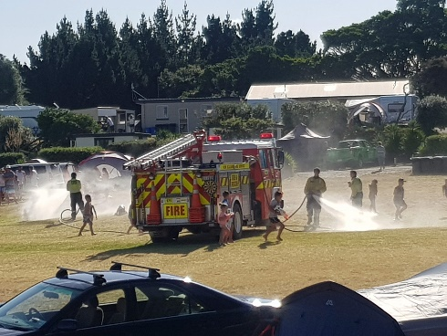
Office hours
from Boxing Day to 7 January 2023
8am to 7pm
8 January to 29 January 2024
9am to 7pm

Security
On site from 7am to 1am every night
during the peak period

EMERGENCIES - please either call 094327590 or press the call button on the keypad by the office door.
Available 24/7

Campers and Visitors:
are required to wear a
wristband the whole
duration of their stay

-Visitors: Register each day
for wristbands

Visitor’s hours: 9am-10pm
Must be registered by 6.45pm

New Years Eve:
Visitors 8am-12:30am.
Visitors need to have
departed Camp by 12:30am.

Safety Notes:
- No gate access available between 10pm and 6am. You will need to park your vehicle out the front if returning after hours
- 5km speed limit at all times around the camp
- Children/Adults not to be in/on the back of vehicles, trailers and boats while driving around the camp
- One car only per site, the car mirror swinger given to you upon arrival must be displayed on your dashboard

- No walking around the camp with open alcoholic drinks
- Please follow the site set up on the map given to you on check in. Tents, Caravan/campers must be set up between the broken lines. Gazebos and cars can come out to the full line. Gazebos can be shared between sites and set up over the lines between the sites.
- No open flame BBQ’s, fires or fireworks at any time
- All caravans must have a current electrical WOF
- Caravans on site must have their draw bar facing the road
- Check out time is 11am, for everyone leaving on the day

Merry Christmas and a happy New Year everyone, we are excited to welcome you to stay with us this year. We are sure you are looking forward to catch up with friends and family again and will make some new friends taking home lots of special memories from your stay in our little paradise.
Our newsletter has handy information relating to your stay, events that are happening and some of the exciting things that have happened since your last stay.
Our camp map has important information and rules that you need to be aware of during your stay so please take time to read it.


Fire Truck:
- Wednesday 27th December
Friday 29th December
- Sunday 31st December
- Tuesday 2nd January
Thursday 4th January
- Could change depending on call-outs

Summer Surprise Patrol:
- Thursday 28th December 12.30-1pm
- Saturday 30th December 1-2.30pm
Will be at the playground with free giveaways and promotions

Marsden Lions Hot Chips:
Unable to be here this year

AGM Meeting

- Sunday 28th January 2024 @10am
- Will be held in our Camp Hall
Fun Day-
- Saturday 30 December @10am atht eh playground

Weather dependent- If raining will be postponed to Easter

Camp Events
Wristbands must be worn at all times

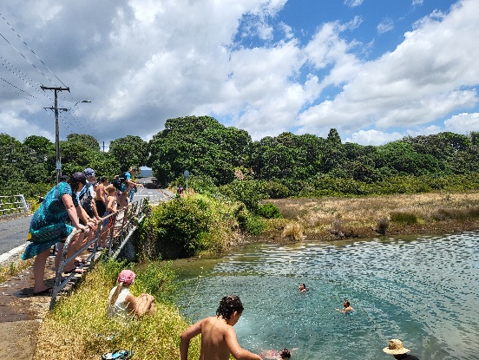
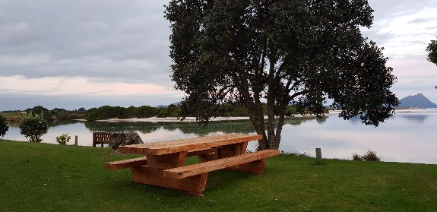
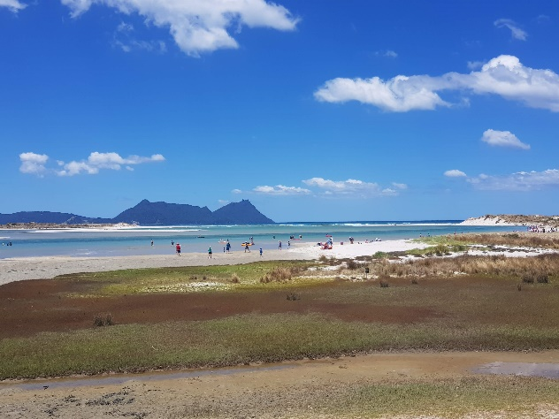

Seawall update –
We are working with DOC, Northland Regional Council and Whangarei District Council to get consent for the seawall. This has been quite a process to work through but the light at the tunnel is starting to look a little brighter. Once we have consent, we can then apply for permits to maintain and repair the seawall. The steps for this have already been started.
whats been happening
We have a grocery store (fresh choice), pharmacy, and much more at the Ruakaka town centre

- Rex & Rats shower dressing rooms
- Pine trees removed on Camp 3&4 bank, new hedging and shade trees planted
- Hedging and shade trees planted in different areas
- Judder bars to help slow traffic down for the safety of children
- Drainage in Camp 1 and Camp 3

Thank you

